User Guide to complete the tax profile

Step 1: Click on the word “Tax Info”



Step 2: Identify if you are filling out the tax form either on behalf of your organization in the US or as an individual. If yes select the radio button on the left.
Or if the above does not apply select the radio button in the right and select the country from the drop down on the right side for which you want to fill out the tax form.

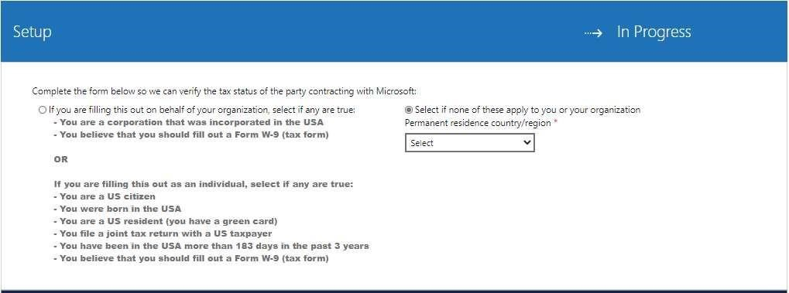

Step 3: Based on your country please select the tax type and complete the details

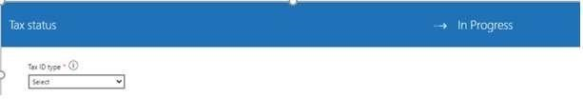

To continue Select “Next”

Step 4: Address should be auto populated based on the information you have entered earlier in the “Contact info” area
If Permanent residence address is different than mailing address, then remove the tick mark, and enter your permanent address.

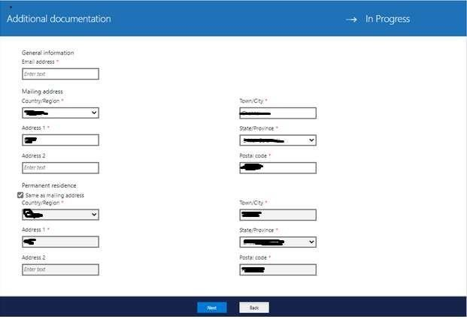
Step 5: Kindly click launch tax form

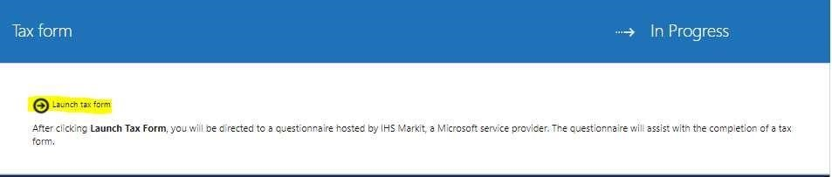
To continue select “Next”

Step 6 : Read the information and check the boxes then enter your First name & last name and click submit.

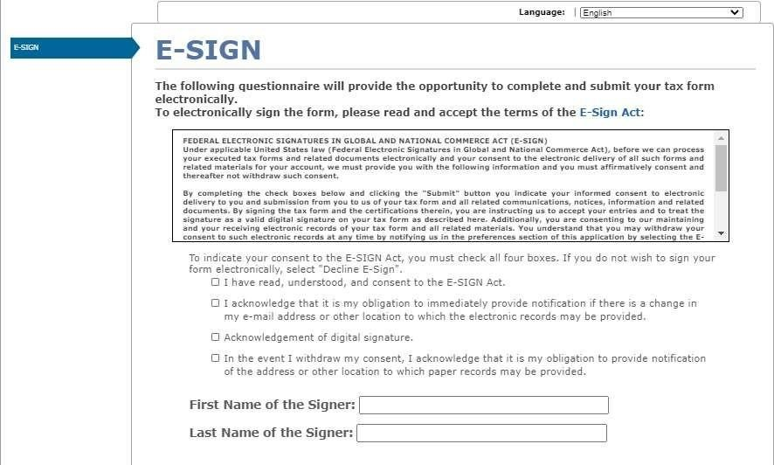

Step 7: Select the appropriate options
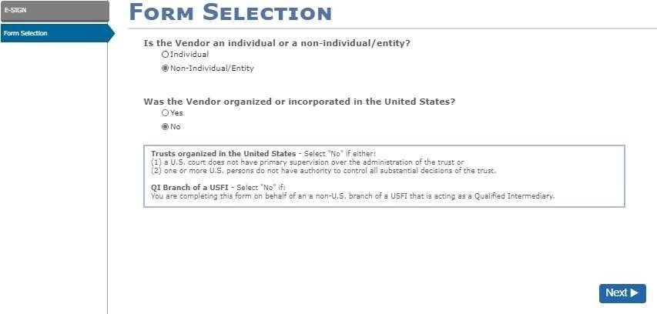

Step 8: Please select the tax form based on your organization type. If you are not aware please check with your Tax advisor.

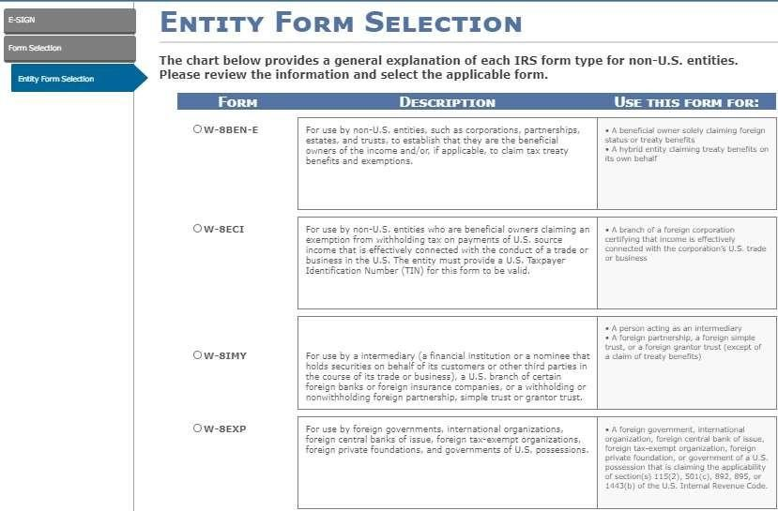

Step 9 : Income Type will pre-selected and is not an editable field. Based on your category/business the correct income type is selected from backend.

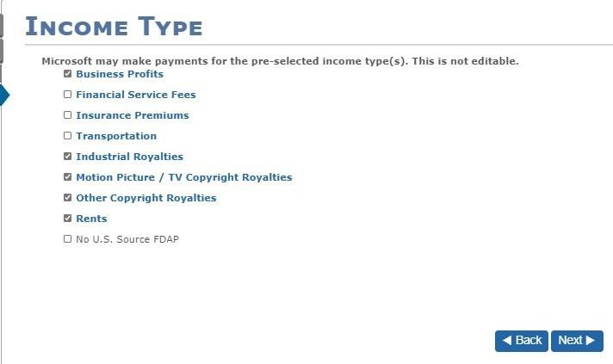
Step 10: Please select the appropriate options for business Entity Type
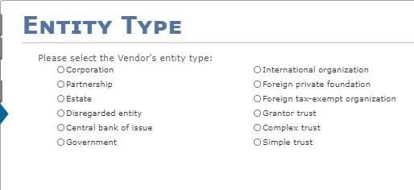

Based on your selections of Entity type you will be asked different questions that needs to be answered.
Example
If you select Entity type as “Corporation” you will be asked below question. Select the correct option.

If you select “Yes” you need to provide the local registration document received from US government and if it is “No” you can proceed further.

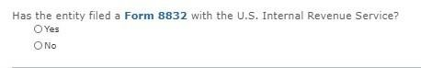
If you select Simple Trust, Grantor Trust, Partnership, or Disregarded entity, you will see below questions. Select the correct option.

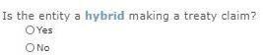
Step 11: Legal name will be pre-selected based on the details given in the contact info tab. Please choose correct option for Disregarded entity
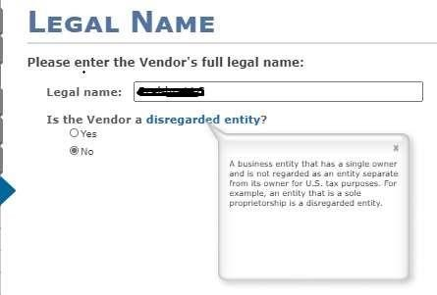
Step 12 : Please select your country of the organization

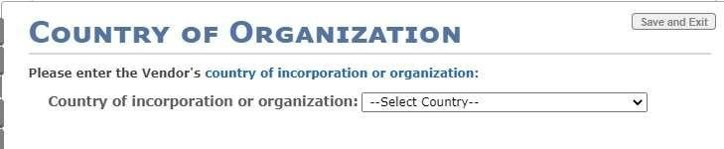

Step 13: Once you enter the country, other details will be pre-filled based on the information given in the Contact info tab. Select correct option for “in-care-of-address”
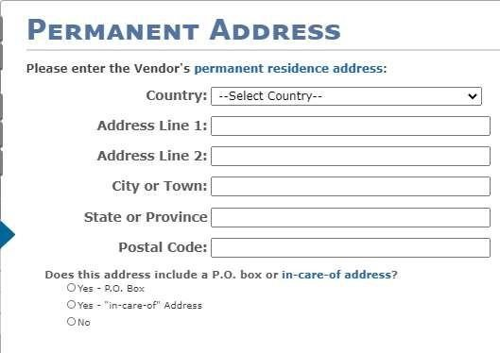

This is not mandatory. If required fill in the details

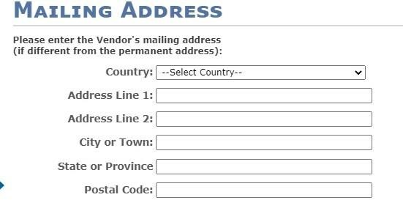

Step 14: Choose the correct option. If you select yes, then you will ask be asked for EIN or SSN based on your Account type (Individual SSN/EIN Organization)
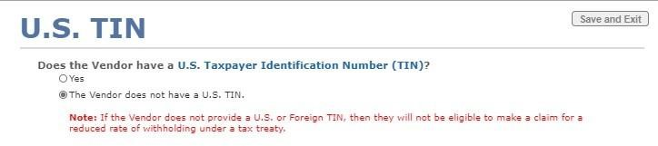

Step 15: Enter your local tax ID.

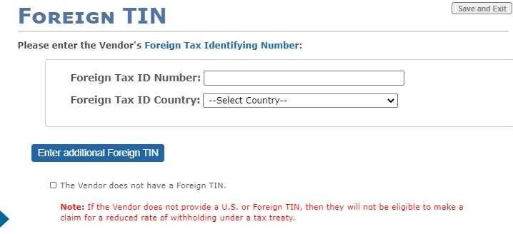

Step 16: Please select correct option based on your country
Based on your selection additional section/quesitons may populate

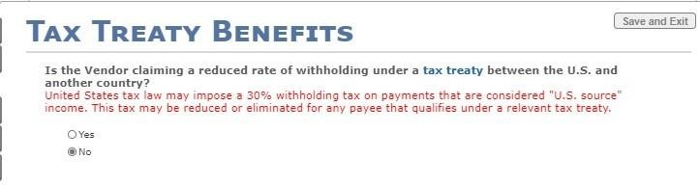

Step 17: If you select yes then complete the below details.
Note: You must select all the Income type, we will pick the correct income type based on your business from backend

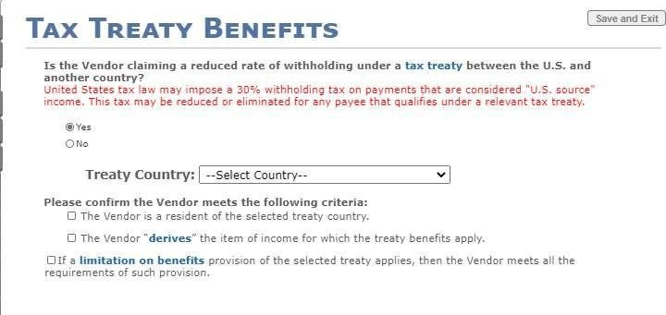

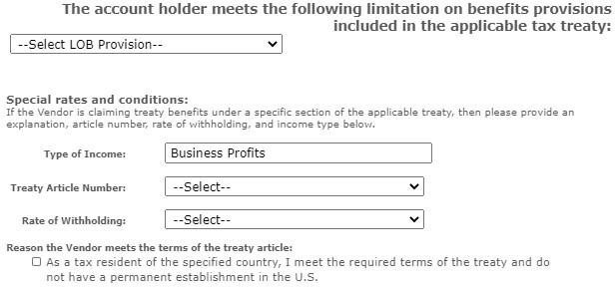
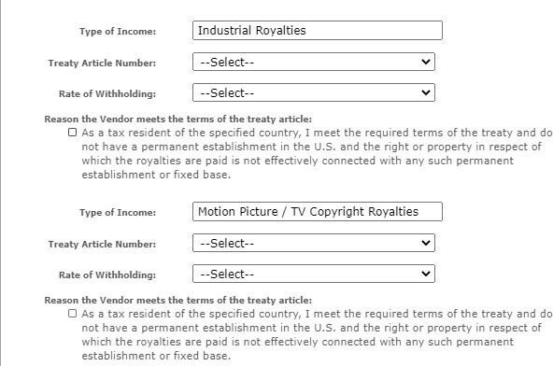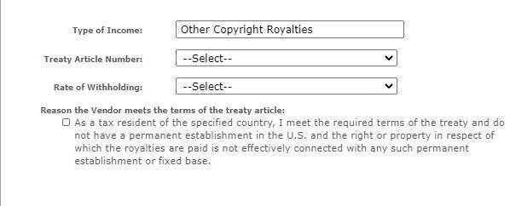

Once you complete the details tax form will be generated. Kindly click on submit.

Step 18: At the end, please read the statements and check the boxes to certify the statements
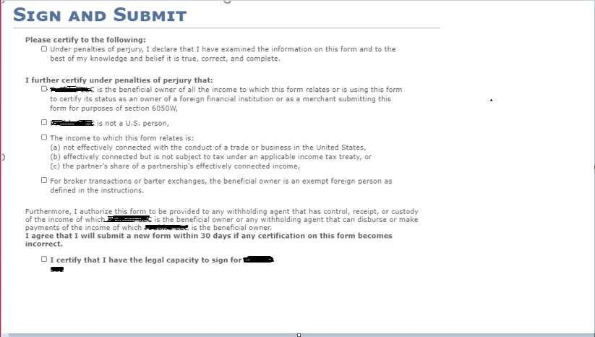

Step 19: Click on the PDF icon if you want to download your tax form. If no, then kindly click on Finish



