Compliance Bulletin #2025-03
Mutual Fund (“MF”) Continuing Education (“CE”) Credits – End of 2nd Cycle November 30, 2025

HUB Capital MF CE Credits Information and Guidance Form

The end of the second cycle on November 30, 2025 is rapidly approaching. As a result, we’d like to remind you of some important steps that you need to take.

Log Into CERTS

Representatives who were registered during the first cycle should be familiar with CERTS, which is CIRO’s system for reporting and tracking CE credits. However we strongly recommend that you log in and check your current balance to ensure that it is correct.

New representatives should log into CERTS to confirm you have access, and to confirm your information.

Note: While our combined regulator is now CIRO, the CERTS page still references the MFDA and includes the old MFDA logo.

To log in/access CERTS, go to Sign In

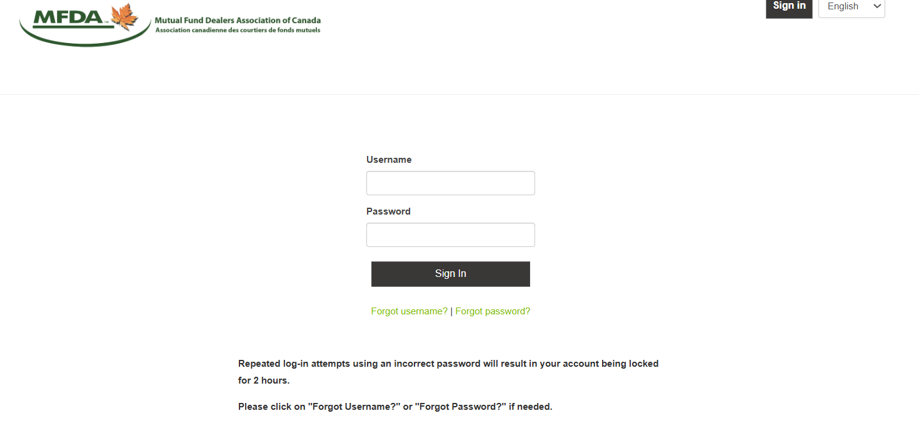

Your ‘Username’ is your MFDA ID.

If you cannot remember your password, please click on the ‘Forgot password?’ link to reset your password.

NOTE: If you have any issues with your log in or do not remember your Username (MFDA ID), please contact the HUB Capital Compliance team via compliancetier2@hubfinancial.com.

Once you log in, you will see a dashboard showing a summary of the current number of MF CE credits you have completed, how many credits are required and the number of credits that still must be earned:

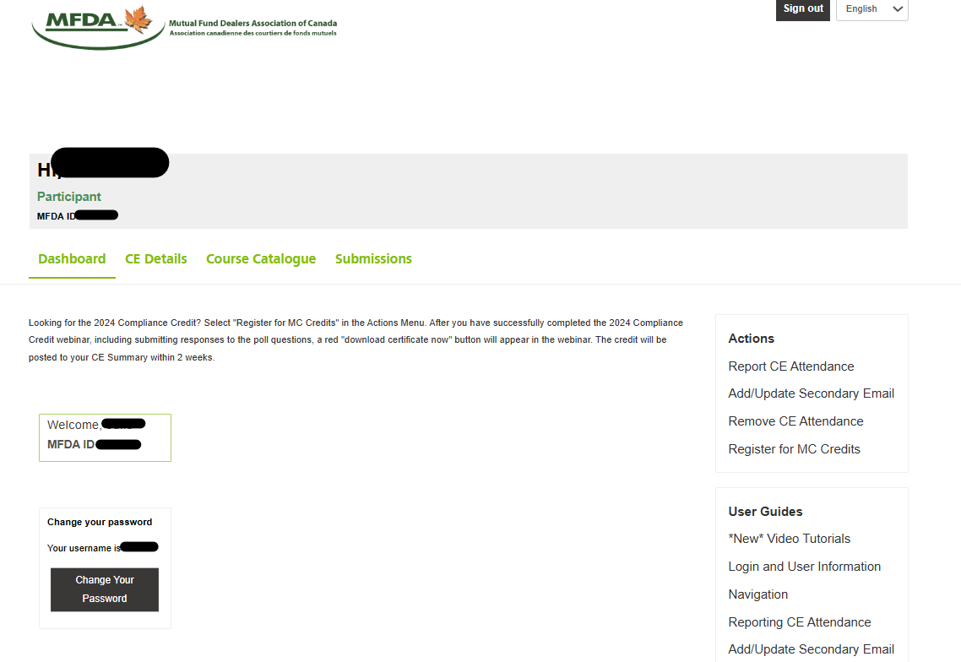

If you click on the ‘CE Details’ tab you will be able to review details on the specific type of MF CE credits that you have earned, and those that are still required. You will be able to view the activities that you have completed under ‘Completed Activities’:

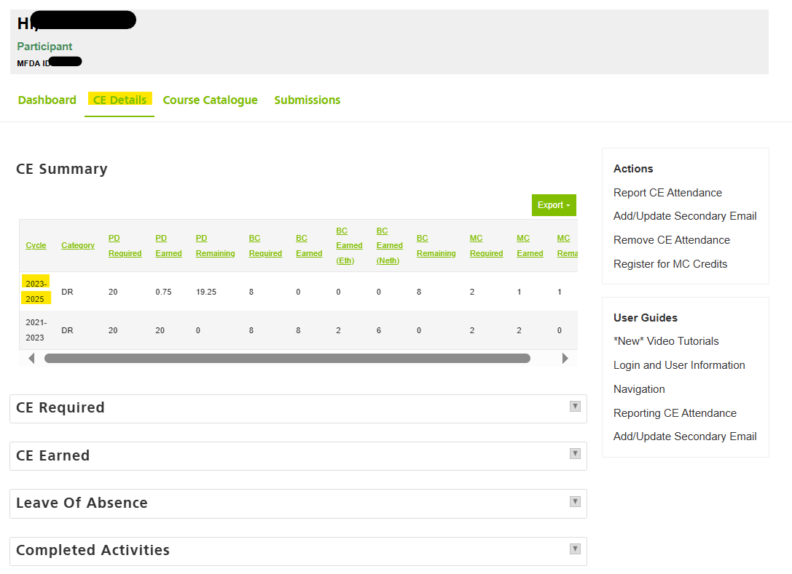

NOTE: Fund companies will not upload your CE credit certificates to CERTS. Your certificates will be emailed to you, and you must upload to CERTS. The same applies to webinars completed through HUB Capital and HUB Financial – you must upload your certificates in order for the CE credits to be counted. Only CE credits for webinars offered through CIRO will be automatically uploaded to your profile in CERTS.

If you have any problems finding a HUB Capital or HUB Financial webinar in the course catalogue on CERTS, please reach out to the HUB Capital Compliance team at compliancetier2@hubfinancial.com for assistance.

Earn MF CE Credits

How many MF CE credits do you need by the deadline on November 30, 2025?

A total of 30 MF CE credits must be earned, in the following categories:

8 – Business Conduct Credits; 20 – Professional Development Credits; 2 – Compliance Credits

# Credits | CE Credit Type | CE Credit Requirements
8 | Business Conduct (BC) | At least 1 hour in at least one of Ethics, CIRO Rules and Policies or HUB Capital Policies and Procedures for complying with CIRO Rules and Policies; and Relevant legislation and its application.  A minimum of 1 and maximum of 2 credits must be content relating to ethics.  Business conduct content is educational material that promotes, directs, and guides ethical and compliant conduct. It includes education regarding ethical issues, CIRO Rules and Policies, other applicable legislation, and HCI’s policies and procedures for complying with regulatory requirements.  Ethics related content refers to content that examines ethical principles and moral or ethical problems that may arise when conducting business through HCI and applies to all aspects of business conduct relevant to advisors and organizations.  Other Business Conduct topics include:  Conflicts of interest; Personal financial dealings; Regulatory requirements and initiatives that affect Member operations; Disclosure of information to clients; Documentation standards; Know-Your-Client; Suitability and new products; Know-Your-Product; Anti-money laundering laws and regulations and related Member policies and procedures; Security and privacy of information; and Complaint handling.
20 | Professional Development (PD) | Professional Development content is educational material that maintains or enhances a Participant’s financial knowledge or proficiency.  A single Professional Development credit consists of 1 hour of training in at least one of the following areas:  Products; Financial planning; Retirement planning; Investment strategies and asset allocation; Client management techniques; Economics, Accounting and Finance; Tax planning; Estate planning; and Insurance
2 | Compliance (MC) | Education material relating to the conduct of Dealers and Advisors that has been specifically designated by CIRO.  Compliance content will include areas relating to, but not limited to, compliance examination findings, CIRO Compliance and Enforcement priorities, and proposed Rule and Policy changes.  These credits can only be earned on CIRO’s website, and must be obtained by completing continuing education activities specifically designated by CIRO.

How can you earn CE Credits?

Fund company websites – most of the larger fund companies offer courses or webinars with CE credits. Dynamic, Mackenzie, and Manulife are some of the fund companies that we have found with extensive course catalogues for advisors to earn MF CE credits.

HUB Capital/HUB Financial – both HUB Capital and HUB Financial offer webinars throughout the year which provide MF CE credits. These webinars are recorded and available on HUBLink.

Please Note: After viewing any HUB Capital/HUB Financial webinars on HUBLink, you must take, and pass, the quiz provided along with the recording to receive your CE credits.

Recordings of all webinars are available through the ‘Continuing Education’ (CE Corner) area on HUBLink, under ‘Accredited On-Demand Courses’:

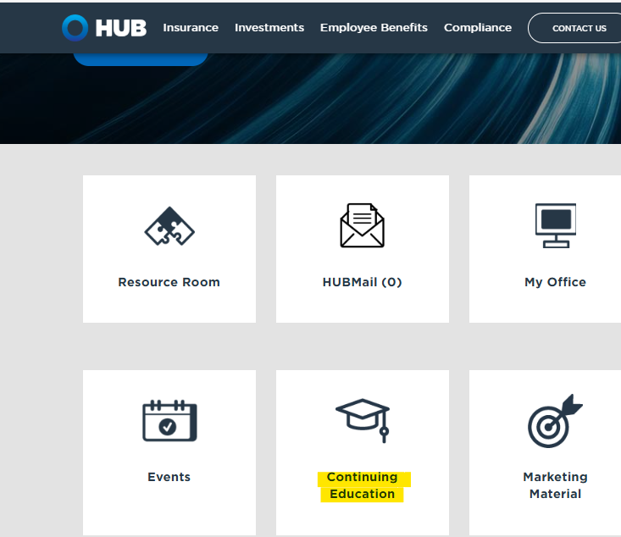

In addition to access to recordings of webinars provided through HUB Capital, the ‘Continuing Education’ page also provides information on how to find more CE credits (including links to Dynamic and Manulife), as well as instructions on how to access your certificates for CE credits through HUB.

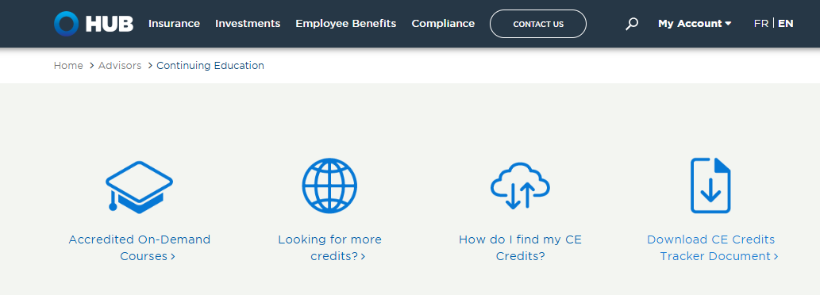

CIRO – there are 2 webinars available from CIRO to fulfill your requirement of 2 Compliance credits for this cycle. Please note these webinars are mandatory and must be viewed to receive your Compliance credits.

These webinars can be viewed by logging into your CERTS account. Under ‘Action’s on the right-hand side, you will see a list of options that includes ‘Register for MC Credits’. When you select this option it will provide a list of the 2 Mandatory CIRO Compliance Credit webinars – one for 2024 and one for 2025.

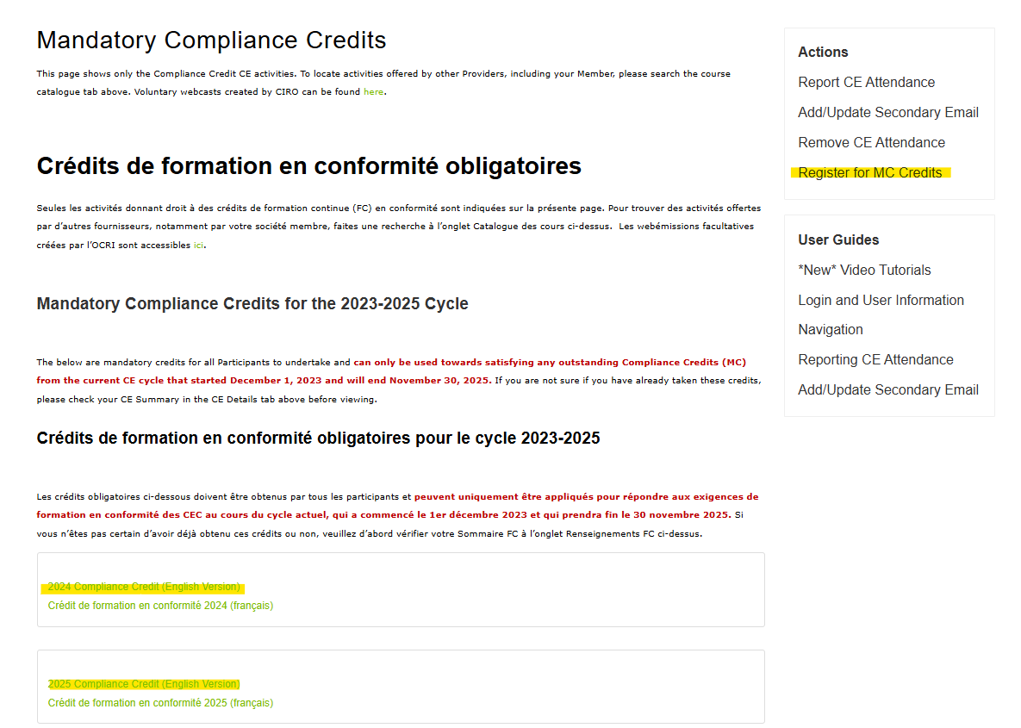

You must select the webinar you wish to view. It will then take you through the steps to register and watch each presentation.

CIRO also has a catalogue of webcasts available on their website that offer various CE credits for mutual fund advisors. The catalogue can be reached using this link: Webcast Catalogue | Canadian Investment Regulatory Organization

Please Note – CIRO will upload CE credits earned to your CERTS profile, usually within 2 to 4 weeks of successfully completing the webinar.

Consequences of Non-Compliance

Representatives who fail to obtain the required CE credits will have their mutual fund registration suspended by HUB Capital. They may also face a fine of $2,500 by CIRO.

Important Reminders

Licensed Assistants – are registered as Dealing Representatives, therefore they are required to earn CE credits and must earn the same amount as an active, selling representative. Licensed Assistants can register for any of the CIRO and HCI/HFI webinars to earn credits – they can also sign up with fund companies to access courses, etc. available on their websites.

Please note – certificates for CE credits earned by Licensed Assistants via HCI/HFI webinars will be emailed to them directly.

Representatives in Quebec – advisors who are only registered in the province of Quebec are not subject to the CE credit requirements. They are only required to satisfy the PDU requirements established by the CSF. However, those advisors that are registered in Quebec as their primary jurisdiction but are also registered in an additional jurisdiction(s) outside of Quebec, are subject to CIRO’s CE credit requirements and will have to complete the required CE credits along with the required number of PDUs.

Please note – many of the credits that can be applied to your PDUs may also be eligible to be applied to your CE credits.

CE Credits Earned Towards Other Licenses, Designations – please be aware that courses and webinars that you have taken to earn CE credits towards your insurance license, CFP or CLU designations may not apply towards your CE credits. You must check the certificate that you receive to ensure it specifically states that CE credits have been earned, and that an Accreditation Number is included for those CE credits.

